Алматы қаласы Алатау ауданы
№26 жалпы білім беретін мектеп
Ағылшын тілі пән мұғалімі
Ргаева Жулдыз Мухаметказиевна
Theme: Ecological problems in Kazakhstan
Aims:to talk about the main ecological problems of our region., to teach pupils to make predications on the theme, to train them to debate and discuss, to enrich pupils knowledge about environment. To develop pupils reading, thinking, speaking
Bringing –up: To teach pupils to keep the environment clean,to protect the nature, to preserve natural resources of our country.
The type: debate
The methods: critical thinking , test, problem solving
The connection with other subjects: ecology, biology, geography.
The aids: interactive board
The plan of the lesson
- Organization moment:
- A:. Greeting
- T: Good morning dear friends. Today we are going to have a talk and discuss the problems of environment protection. Many people all over the world are concerned about the ecology today. The word “ecology” came from the Greek language which means “home”. This idea of “home” includes the whole planet of ours. But it is in great danger nowadays because it has been suffering from many environmental problems. Can you name some of them. Fill in this word web:
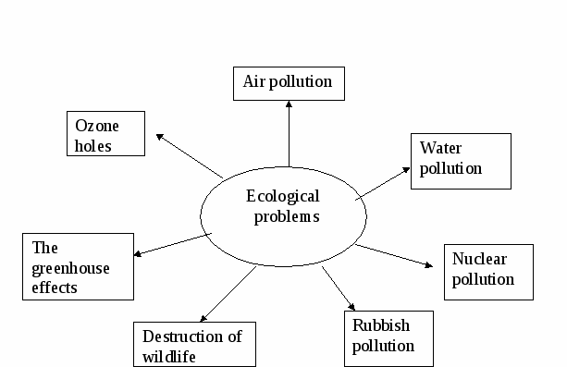
Where does air pollution mostly come from? (from cars, buses, plants, factories)
- What can appear as the result of air pollution? (holes in the ozone layer)
- Why are holes in the ozone layer dangerous? (ultraviolet radiation from the sun can cause skin cancer)
- What makes the sea water dangerous? (testing of nuclear weapon? Dumping industrial and nuclear waste)
- Why is it dangerous to dump industrial waste in the sea? (this poisons and kills fish and sea animals)
- Why are nuclear power stations dangerous? (they can go wrong and cause nuclear pollution)
- Why have some species of animals become endangered? (the man kills animals and destroys their habitats).
T: So you have just mentioned main ecological problems of our planet. You know people all over the world try to solve these problems in different ways. Let us read about the ecology in Kazakhstan.Look through the sentences once and find the descriptions of the following pictures.
- We sort our rubbish: there are special containers for paper, tins, food, white glass, brown glass and green glass. After that special factories recycle these materials and people reuse them.
- We never drop litter in the street. If somebody sees you, you have to pay a fine.
- We never forget to turn off lights and water. Water, heating and electricity are expensive!
- A lot of people use public transport. They don't go by cars, because firstly, cars pollute the atmosphere and secondly, because it's very difficult and expensive to park a car in a big city.
- We clean up after our dogs with special pooper scoopers. If we don't — the fine is £50.
- Our winters aren't very cold, so nobody wears fur coats. If you wear a fur coat, sometimes people from Greenpeace spray your coat with paint. "Wemustn'tkillanimalsforclothes," theysay.
- When we go camping, we never make campfires. Weusecampingstoves.
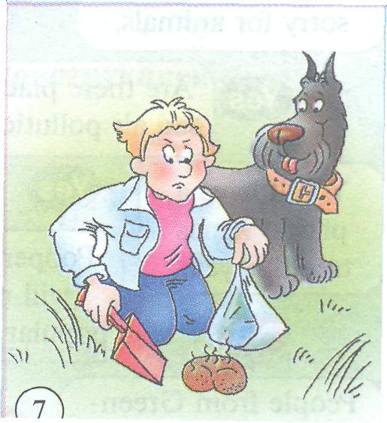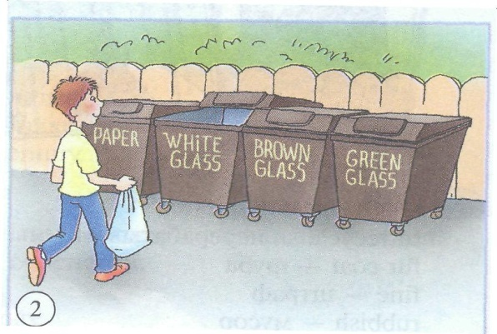
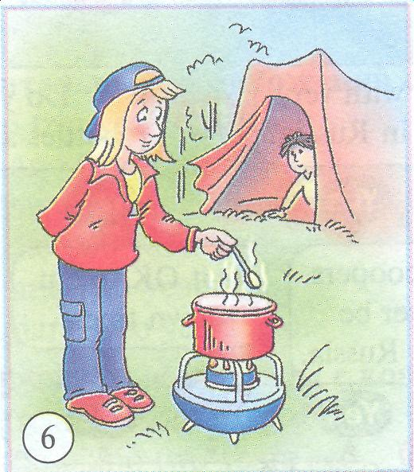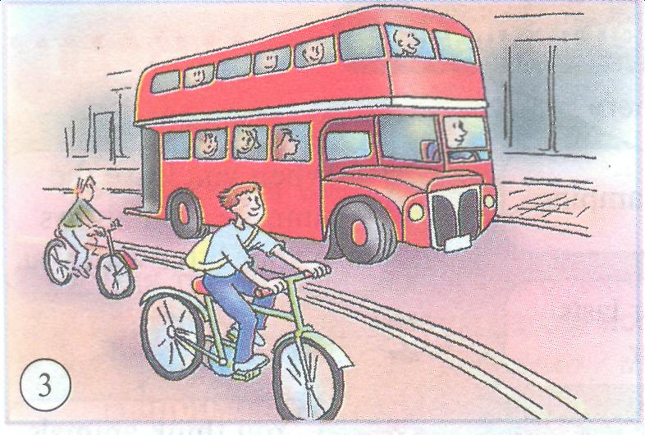
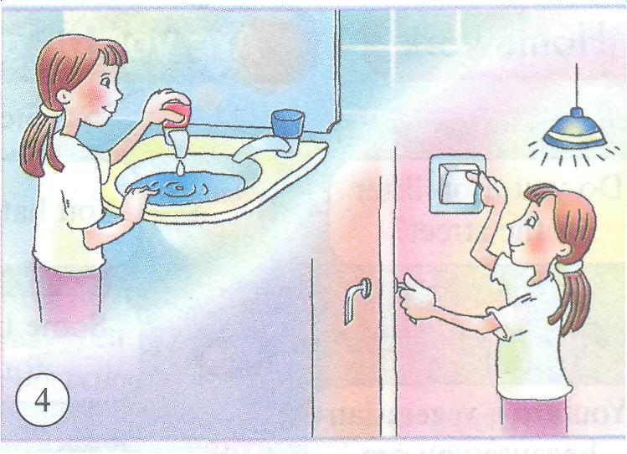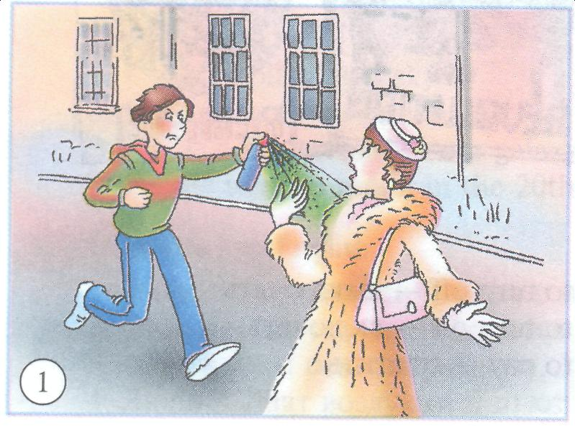
T: We have just read about environment in Britain. We live in a large city. Do you think it has such problems too? Our girls have studied ecology in Almaty. Let’s listen to them.
Ecological problems of Almaty.
Hundreds of smoky industrial enterprises pollute the air we breathe. Each of us breathes 151 kilogram polluted air in Almaty every year. It's quite enough to cause cancer.suffer from smog. Exhaust fumes from cars and buses are the biggest problem for air pollution. It is rather dangerous to live in the centre of Almaty, in the areas of Kapotnya, Lyublino, Brateevo, because the air is polluted here, it's not safe to breathe it. In the south-east of Moscow Zhulebino and Kuzminki are the cleanest places.
Forests around the city are cut down and sometimes burn in fire. Their disappearance upsets the oxygen balance. Many animals, birds, fish and plants disappear forever or leave their habitat.
The quality of the water we drink leave much to be desired. 8 per cent of water is not allowed for drinking, so we must boil it before drinking. The Almaty -river, the Yauza-river are polluted and turned into the biggest dump for waste. The water in these rivers is so dirty that fish cannot live there, it is dangerous to eat it. Today it is dangerous to swim in most lakes and ponds ofAlmaty.
T: Much attention is paid to the environmental problems at our school. You take part in different meetings and conferences devoted to this problem and after all you take part in different drawing contests and try to attract our attention to this problem by the posters. Here you can see some of them.
^ V.
T: Not only people can speak. Books can speak too. There is a kind of book which screams. It’s the Red Data Book. It’s a reference book on rare and disappearing animals. Why is it “Red”? The colour red is a danger signal understandable to all people in the world. The colour red is one of blood and life. You should hear the world around you. It calls for help.
Fortunately there are a lot of environmental organizations in the world.
-Do you know any of them? (“Green Peace”, World Wildlife Fund”)
-What is their aim? (to protect nature and to save the world)
Today we have representatives from different countries. Let’s listen to them.
VI.
T: Unfortunately we don’t have guests from Britain today, but they sent a video film to us about their wild world. Let’s watch it.
But first look at the blackboard. There are some new words. Let’s read them and try to understand.
-fallow deer – лань
-badger – барсук
-spine – иголка
-highland – горнаяместность
(Scottish Highlands)
- century – столетие
T: Now watch the film. You will watch it twice. Then you’ll have to do some tasks. Read through statements 1-8. As you listen, decide if each statement is true (T) or false (F) according to the information you hear.
There are about 30,000 different kinds of animals in Britain. The fallow deer is one of the most attractive wild animals. It's also one of the easiest to see because they live all over Britain. Fallow deer live in the countryside but you can see them in some parks too.
One of the smallest wild animals is the field mouse.
The largest wild animal is the red deer. Many years ago they lived all over the countryside, but now red deer live mainly in the Scottish Highlands.
The badger, of course, is much smaller. You can easily recognise a badger because of its black and white nose. They usually come out at night so you'll be lucky to see one.
Rabbits are easier to see, especially early in the morning and in the evening.
This is a hedgehog, the only British animal with spines.
Foxes usually live in the countryside. As more and more countryside is disappearing, some foxes are learning how to live in towns.
However, not all animals are so good at changing their habits, and some animals need protection from others. This is a red squirrel. Two hundred years ago red squirrels lived all over Britain. Then in the 19th century the grey squirrel came to Britain from North America. The grey squirrel is a little bit bigger than the red squirrel and it's much better at finding food.
Nowadays you can only find red squirrels in Scotland and some parts of England.
The golden eagle also needs protection ... but from humans. It's one the rarest British animals. There are just over 800 golden eagles left in the wild. They are one of the largest British birds and one of the most beautiful. There are a total of 116 protected species of animal in Britain.
- There are about 3, 000 different kinds of animals in Britain (F)
- Fallow deer live all over Britain. (T)
- The red deer is the largest wild animal.(T)
- Badgers come out in the morning, so you’ll be lucky to see one.(F)
- You can see foxes only in the countryside.(F)
- The red squirrel needs protection from the grey squirrel.(T)
- There are a lot of golden eagles in Britain. (F)
- There are 116 protected species of animals in Britain.(T)
T: Now do the tasks. I’ll give you 3 minutes.
VI.
T: We have mentioned a lot of ecological problems. We have discussed their reasons. Do you think that only grown-ups should care for environment? What can children do to help nature? You can use the table on your sheets of paper.
 |  |  | reduce using electricity and water
 |  |  | leave litter in the streets
 | should |  | breakstrees
 |  |  | takecareofbirds
 | can |  | disturbwildanimals
We |  | not | feedbirdsinwinter
 | may |  | reusethings
 |  |  | driveourcarsless
 | must |  | recycle paper, cans and glass
 |  |  | planttrees
 |  |  | let fires burn in the forest
 |  |  | damagebirds’ nests

VII. Conclusion
Our lesson is over. I’m sure that you are real friends of our planet. And you will save it for ourselves, for the future generation. All of you will get good marks.
At home think over and write a letter to the mayor of our city about the ecological problems of Almaty, give convincing arguments, ask him to take some measures.

